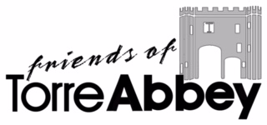

To join the Friends of Torre Abbey please complete this form, include a cheque for the appropriate amount payable to ‘Friends of Torre Abbey’ together with a stamped, self-addressed envelope and send it to:
Alan Gardiner
FOTA Membership Secretary
Wheatridge House, Wheatridge Lane, Torquay, TQ2 6QZ

Please use this form for both single or joint membership
Title(s)

First name(s)

Surname

Home address

Post Code

Telephone No.
________________________________________________________

Email address

I /we have read the FOTA Privacy Policy and consent to the use of the above data for FOTA use only in accordance with the FOTA Policy.

Signed

Date

Gift Aid declaration
If relevant, please complete the Gift Aid Declaration as part of your application, since this will enable FOTA to reclaim the tax from the Government.

Please treat as Gift Aid donations all qualifying gifts of money made today and in the future.

I confirm I have paid or will pay an amount of Income Tax and/or Capital Gains Tax for each tax year (6 April to 5 April) that is at least equal to the amount of tax that all the charities or Community Amateur Sports Clubs (CASCs) that I donate to will reclaim on my gifts for that tax year. I understand that other taxes such as VAT and Council Tax do not qualify. I understand the charity will
reclaim 25p of tax on every £1 that I give on.

Signed

Date

Please notify FOTA if you want to cancel this declaration, change your name
or home address or no longer pay sufficient tax on your income and/or capital gains.

